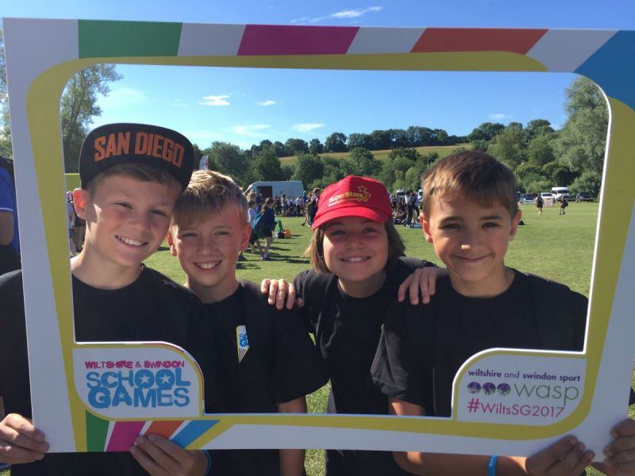  What does Sport mean to you?  Complete the following  I enjoy taking part in sport because…….  I like helping at sport events because…..  Max 150 words | Your writing will be published in Relay, local papers and on the WASP website  ────  It will feature in the School Games video  ────  Win Amazon vouchers  ────  Closing date  26th March 2018  Submit Entries with  full name, school  and year group  to  Alma Borthwick  alma@wiltssport.org

